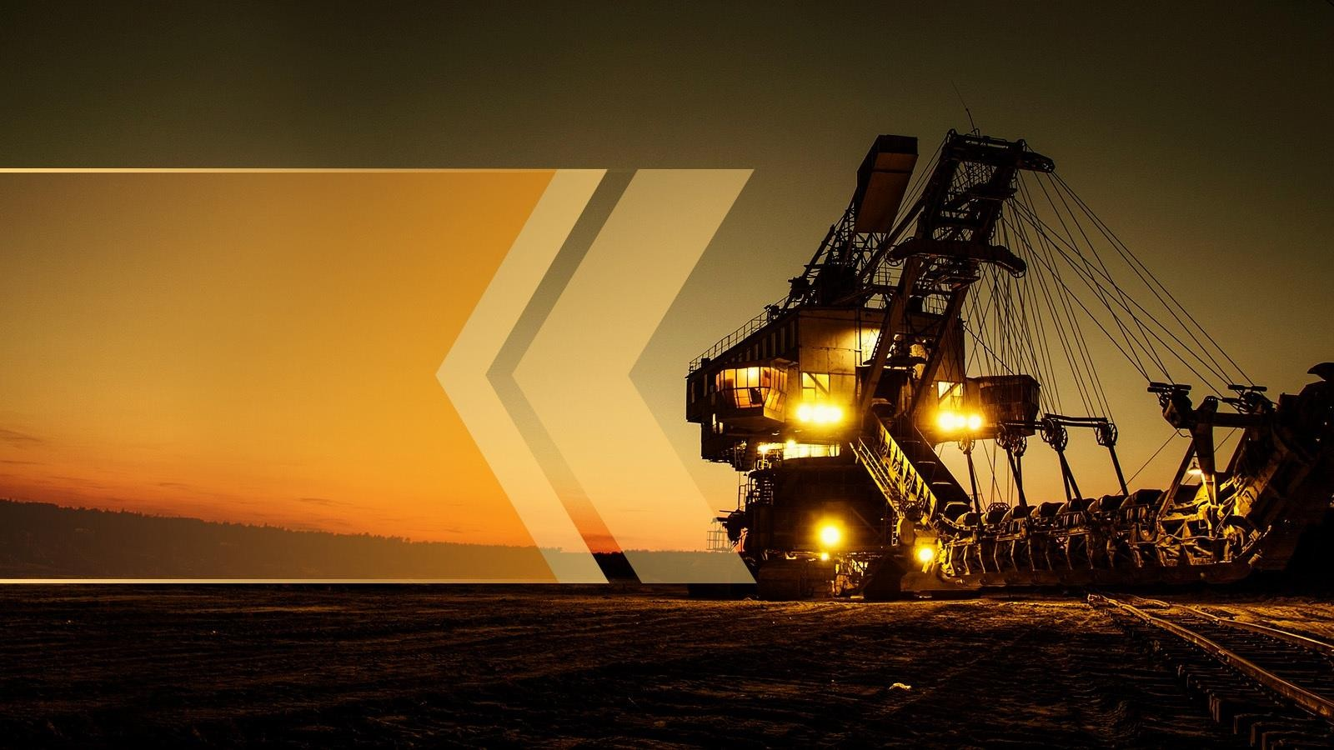
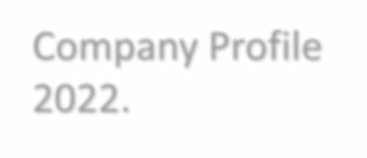

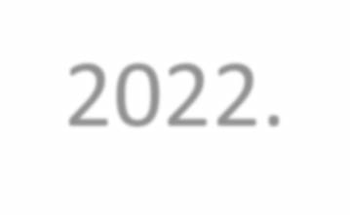

Company Profile 2022.



FE.


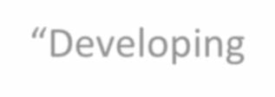

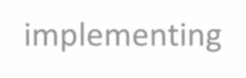












INTRODUCTION

Trafe is an international Crude & Petroleum Product Supply with Drilling service, Operating world wide with offices in The USA, Netherlands, UK, Switzerland, Kuwait and Oman. Our Group is a forward-thinking organization who tries to make difference in the world by: “Developing and implementing innovative solutions to the world’s most complex challenges.”.

We believe our pioneering spirit will deliver superior solutions for our clients. We are dynamic, brave and purposeful, breaking through barriers and charting new ground, genuinely making a difference but always with a conscience. We aim to create opportunities where others have not, We search for sustainable solutions where others can not. We develop revenue-generating solutions to common and complex industry challenges.

An EPC contractor, having Crude & Petroleum Product Supply division, with a fast growing worldwide client base, specialized in a full range of drilling services. Trafe provides tailor made drilling teams, full overhaul, spare parts and certifications for your drilling equipment. Our staff is motivated, well trained, certified and ready for any job.
Your problem is our GOAL


CEO’s Speech

The idea behind Trafe leads back more than 20 years ago were a couple of Dutch no-nonsense sailors who had already earned their spurs in the offshore, decided to work together worldwide to carry out the most complex assignments, alone or in a team.
All educated and trained by experiences with high pressure drilling in the most complex form near the coast of the Netherlands and England in the dreaded North Sea.
That sense of invincible seamanship is still the drive that all our employees radiate. Wherever they are. Whatever problem needs to be solved.
Now that Trafe Group of Companies has grown into a globally operating company with a large database of specialists for every job, we no longer see each other every day. But the feeling remains of that group of friends who see every problem of the customer as a challenge.
That is what Trafe Group of Companies still stands for: Your problem is our challenge!
Michael Fokker, CEO


SUSTAINABILITY

Sustainability- Deeply embedded in Trafe everyday business
- Human and labor rights.
Human rights has been one of the key elements of our sustainability in the recent years. With our work, we aim to make positive impacts for our employees and other stake holders in our value chain towards the earth, our climate and social environments.
- Environment officer
We at Trafe decided already in 2016 that with the work we do all over the world we had to take our responsibility towards our environment. We decided to bring in an environment officer who is 24/7 dedicated working towards possible solutions for our work with regards to the environment. This has led towards a good knowledge of the impact of our work to climate change, supply chains, work circumstances and possible sustainable materials to be used.
- Climate
According to our purpose and vision, we at Trafe aim at leaving a healthier planet for our children by creating choices every day. We advise on day to day bases our customers to reduce emissions by developing lower emissions solutions. We actively arrange workshops at our working sites together with our clients to introduce solutions for emissions reducing and a better climate.
- Our employees
One of our standards is a zero accident protocol which means that we try to avoid all risk or any danger during the executions of our jobs. These zero accident protocols have been embedded in procedures and also in our tools and protecting measurements towards our employees.
Our day to day communications with our employees worldwide is to give them a family feeling and to see Trafe as their second home.
We at Trafe are having an active policy by trying to get women on leading positions into the company. We work together as a family regardless of your religion your nature and social background.


MEMBERS OF BOARD



CEO:
Michael C. Fokker

Founder and President of the Board of Trafe Group of Companies. As an AAA accountant
specialist in International Financing. Over 40 years’ experience in the Financial and Juridical fields. With his extensive knowledge of leading international companies, he participated in various international trade missions for The USA and Netherlands. Late member of The Fokker Family.


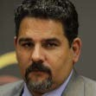
COO:
Bouda Kirroh

Bouda has more than 20 years’ experience, worked for some of the major companies within the marine /oil&gas and drilling equipment
Industry, hold various key both technical and management positions world wide. Demonstrated history of working in the international trade and development industry. Strong business development professionally with a various Certificates in Marine, Oil & Gas and Drilling.



MEMBERS OF BOARD


Head of Legal:
Nicole Weinstock

Ms. Nicole is head of our legal team and responsible for all contracts and risk
management. Nicole has studied International Tax Law and after graduation she has been promoted at Mannheim Business School. Her business codes are straight forward, honest and respect. With many years of experience in international contract rights she is a honorable member of our management team.

Sales/Marketing Director:
Mike Williams

Expertise with over 25 years experience, with exposure to the upstream and downstream domains of the oil & gas industry, having held various key management positions
worldwide. Demonstrated history of working in the international trade and development industry. Strong new business acquisition acumen, new market development, project acquiring. Leading our global sales teams towards the highest rates of customer satisfactions. Responsible in our Board for the worldwide sales of the Trafe Group of Companies.






WHAT WE DO -

# FUEL SUPPLY
# CRUDE OIL SUPPLY
# DRILLING SERVICES


# OTHER TECHNICAL SERVICES

WHAT WE DO -

FUEL SUPPLY
Trafe with our EPC background have been successfully able to establish as a key Fuel Supply company to various regions of the world..
We are proud to mention our capabilities to supply fuel in Bulk originating from Oman, Finland, Norway, Kz, Qatar & Fujairah. Additionally Trafe has its own Fuel Storage facility in Sohar Port, Oman with a capacity of 9Million Barrels, 2nd phase scale up to 12 Million Barrels, followed by 18 Million Barrel Storage capacity.
The products we supply are as follows –
- CRUDE OIL
- EN590 10PPM
- GASOIL 50 PPM
- GASOIL 500 PPM
- GASOLINE ALL GRADES
- A1 JET FUEL
- D2
- LPG

DRILLING SERVICE PARTNER
Trafe is an EPC contractor with a fast growing worldwide client base, specialized in a full range of drilling services.
Trafe provides tailor made drilling teams, full overhaul, spare parts and certifications for your drilling equipments.
Our staff is motivated, well trained, certified and ready for any job.
Your problem is our GOAL
We offer the complete package of services, employees with proper training and necessary certificates.
Trafe is also active in projects and product development.
Example; we are actively involved with mobile video surveillance
systems that are widely used in offshore, shipping and construction.

WHAT WE DO -


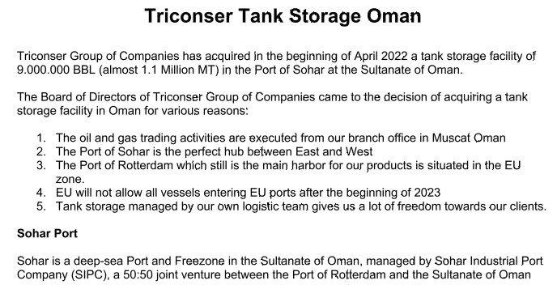

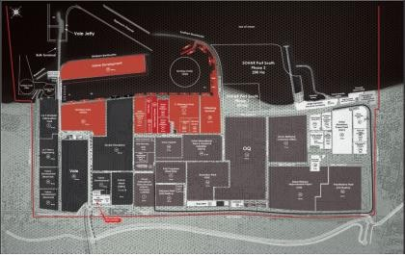
SOLUTIONS
Trafe Group of Companies has acquired in the beginning of April 2022 a tank storage facility of
9.000.000 BBL (almost 1.1 Million MT) in the Port of Sohar at the Sultanate of Oman.

The Board of Directors of Trafe Group of Companies came to the decision of acquiring a tank storage facility in Oman for various reasons:
TRAFE TANK STORAGE OMAN

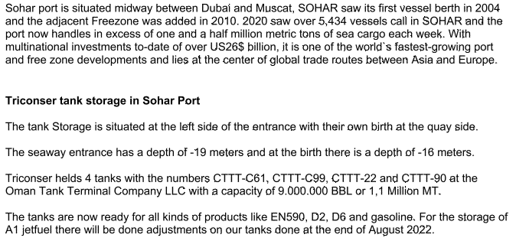

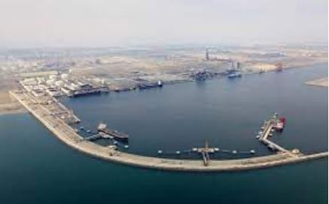
SOLUTIONS
Trafe Tank storage in Sohar Port
The tank Storage is situated at the left side of the entrance with their own birth at the quay side.
The seaway entrance has a depth of -19 meters and at the birth there is a depth of -16 meters.
Trafe helds 4 tanks with the numbers CTTT-C61, CTTT-C99, CTTT-22 and CTTT-90 at the Oman Tank Terminal Company LLC with a capacity of 9.000.000 BBL or 1,1 Million MT.

The tanks are now ready for all kinds of products like EN590, D2. D6 and gasoline. For the storage of A1 jet fuel there will be done adjustments on our tanks done at the end of August 2022.

We offer the complete package of services, high skilled specialists with proper training and necessary certificates.
Trafe will provide you the right specialists for performing the following disciplines.

- Managing and hands on drilling rig activities on Drill ships Semi-submersible &jack up drilling rigs.
- Engineering.
- Operating.
- Maintenance.
- Overhauls.
- Factory Acceptance Test Witnessing.
- Quality insurance as third-
party witness.
- Preservation of drilling rigs for prior being stacked.
- Returning drilling rigs back into operation.
- Equipment repairs.
- Inspections.
- Engineering, Design and
Construction Services.
- Technical Manpower Services.
- Security Services for Oil and Gas Assets.
- Sourcing and supplying parts and components. New and used.

SOLUTIONS

In cooperation with our worldwide network of specialists Trafe is able to manage the following services

  - Oil and Gas Exploration and Development
  - Oilfield Services
  - Drilling and work over fluid
services
  - Environmental services

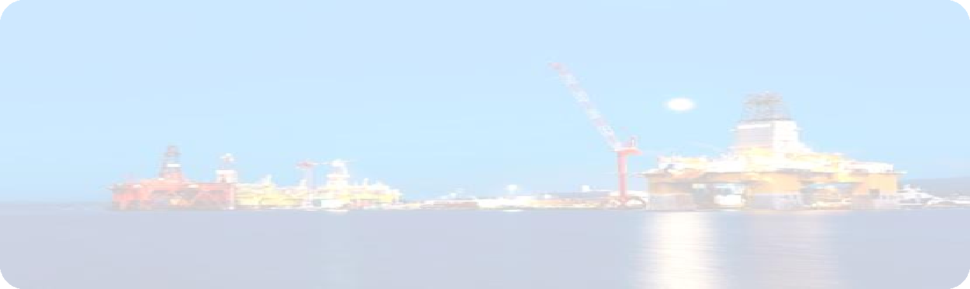
  - Well testing and early production facility Engineering, Design and Construction Services
  - Technical Manpower
Services for well testing
  - Security Services for Oil and Gas Assets


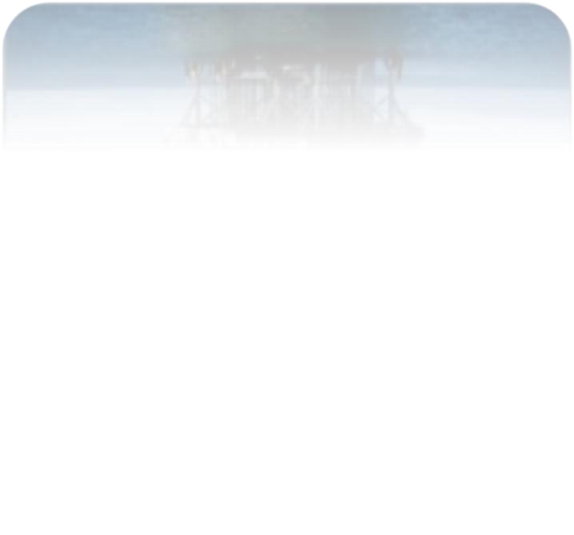
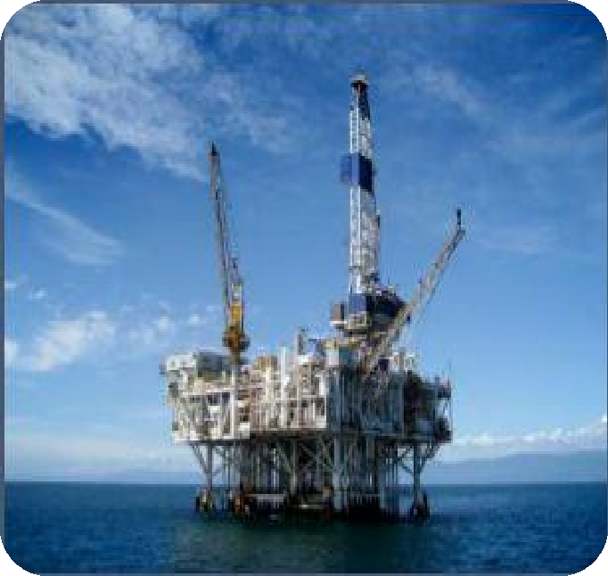
OIL & GAS EXPLORATION & DEVELOPMENT

The partners of Trafe have many years of experience in Energy development and discovery, and a vast network of associates, providing following services:

    - Reservoir studies - Field studies
    - Field development plans
    - Work programs and
operations management
    - Sourcing and supplying parts and components
    - Overhauling, repair and maintenance
    - Offshore jack-up and Semi-sub operations
    - Financing and finance
planning


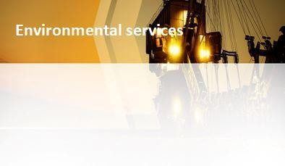
DRILLING & COMPLETE FLUID SERVICES

      - Multilateral drilling
      - HTHP drilling and evaluation
      - Completion fluid filtration
      - Reconditioning of drilling and completion fluids
      - Fluid analysis

        - Feasibility studies
        - Site assessment
        - Oil waste management
        - Soil remediation
        - Vessel and production tank cleaning

WELL TESTING & EARLY PRODUCTION FACILITIES

- Production testing
- Well cleanup
- Extended well testing
- Data acquisition and interpretation
- Fluid samples and analysis
- Design and manufacturing capabilities
- Build-Operate-Transfer
- Operations and maintenance
- Flexible commercial models




CASED HOLE SERVICES

  - Gamma ray/CCL
  - Radial cement bond tools (RBT)
  - Multifinger imaging tool (MIT) and magnetic thickness tool (MTT)
  - Pulse neutron neutron (PNN) tool
  - Production logging tool (PLT )



TRACK RECORD

- Onshore Drilling Sultanate Of Oman, 3 LR 15 wells5 years contract
- Onshore Drilling KOC, Kuwait, KOC 2 LAND RIGS, South of Kuwait, 12 wells.
- Supervised rig acceptance and prepared the drill ship ODN 1 for contract with
Petrobras
- Changed out complete Aker CMC on location (first ever and only) on the ODN 1
- Supervised rig acceptance and prepared the drill ship ODN 2 for contract with Petrobras.
- Prepared drill ship Norbe 8 for contract with new client “TOTAL”
- Installed Acoustic BOP control system and auto shear system upgrades on the BOP system on Norbe 8.
- Supervised and managed 5 yearly recertification of all well control equipment
Norbe 8 on location.
- Supervised and managed 5 yearly recertification of all well control equipment Norbe 9 on location
- Supervised and managed completion of construction, rig acceptance and prepared the semi-submersible DELBA 3 for contract with Petrobras.
- Supervised and managed rig modifications and recertification Semi-Submersible drilling rig ODN Tay former Stena Tay.
- Developed and installed new BOP control system on drill ship Noble Roger Eason.
- Developed and Installed Cyber chair drilling control systems and replacement of
complete drilling package on Jack up Rig Noble Al White.
- BOP recovery on Semi-Submersible ODN Tay.
- Well examinations for geothermal projects in The Netherlands, including wells CAL-GT-01,CAL-GT-02,CAL-GT-03,HEK-GT-01,HEK_GT-02
- Well examination schemes for Dutch based drilling company
- North Sea HSE cases for all drilling units of a drilling contractor
- ISO140001 audit program for mobile drilling units
- Quantitative Risk Assessment for the Borehole Drilling project in Republic of Ireland.



